**SMART PIG BARN EQUIPMENT CONTROLLER**

**Team Leader:** Vũ Trần Tuấn Sơn

**Group members:** Nguyễn Đức Duy, Vũ Phụng Anh, Phùng Long Vũ, Phạm Thanh Long

**Adviser**: Khuất Đức Anh

# **Abstract**

*Currently in our country, the application of smart controllers in farm animal husbandry is developing quite well. There are increasingly more businesses investing in this production method to ensure an adequate food supply for the market. manual is still used, it will not only be costly but also difficult to ensure uniform and stable quality in animal care. To ensure investment efficiency, it requires synchronized and standardized management processes and operational activities the farm, with animal care being mechanized and automated to meet the demands.*

*The smart pig pen product designed to enhance the efficiency and productivity of pig farming. This advanced system combines features such as automatic feeding, cooling the pen, and self-cleaning to simplify pig pen management.*

*Automatic feeding function uses real-time modules and an intelligent feeding trough system to provide pigs with food at the right time and in the right amount. The pen cleaning system uses water pumps, automatic spray nozzles, and can clean every corner of the pen to maintain cleanliness and prevent the accumulation of and disease-causing pathogens. In addition, the smart pig pen also has automatic cooling capabilities through integrated temperature sensors and fans. This cooling system uses advanced technology and intelligent sensors to effectively cool the farm environment, ensuring the health and productivity of the pigs.*

*By integrating automatic feeding, cooling, and self-cleaning functions, the smart pig pen brings many benefits to pig farmers. It improves food utilization efficiency, reduces requirements, and promotes animal welfare by providing a clean and controlled environment.*

**Keywords:**

# **1. Introduction**

## **1.1. Rationale of the Study**

In recent years, pig farming in our country has experienced fluctuations in the total number of pigs and meat production. The highest total pig population was reached in 2016 (29.1 million pigs), which decreased to 27.4 million pigs in 2017 ( to surplus crisis), then increased again in 2018 (28.1 million pigs). However, it suffered a significant decline in 2019 due to African swine fever (only 19.6 million pigs remained). The pig population gradually recovered in 2020 (22.0 million pigs) and continued to grow, reaching 28.1 million pigs 2021 (the output of live pig meat reached 4.18 million tons, accounting for 62.5% of the total meat production in the country)[1].

The project "Smart Barn Equipment Control System for Pig Farming" is a system designed to apply technology to the pig farming industry. For pig farmers, efficient management and care of pig barns are crucial to ensure health and enhance farming productivity. With the development of technology, this control system has been developed to optimize daily operations in managing the pig barn environment.

The main objective of the project is to provide a comprehensive automation platform for pig barn management. By using sensors and digital devices, the control system collects information about the pig barn environment such as temperature, humidity, air quality, and lighting. This data is transmitted to the control system for analysis and display through a user interface.

## **1.2. Introduction to the project**

Project "Smart Pig Barn Equipment Controller" creates a smart pig barn management system that helps pig farmers optimize their farming operations. By using this controller, pig farmers can control and adjust important factors such as temperature, feed quantity, and scheduled cleaning of the barn.

The controller is designed with high flexibility, allowing pig farmers to customize and schedule barn management activities based on specific requirements. For example, they can set the ideal temperature and humidity in the pig barn, and the controller will automatically adjust the temperature control and water irrigation systems to ensure a comfortable and suitable environment for the pigs.

Additionally, the controller also supports automatic feeding and scheduled barn cleaning. Pig farmers can set schedules for feeding and waste disposal, helping to enhance farming efficiency and save labor efforts.

The "Smart Pig Barn Equipment Controller" project brings many benefits to pig farmers and the pig farming industry as a whole. By automating the pig barn management process, this project helps enhance farming efficiency, reduce labor efforts, and increase the sustainability of the pig farming industry. Moreover, it contributes to minimizing negative impacts on the environment and enhancing the quality of pork products.

In summary, the "Smart Pig Barn Equipment Controller" project aims to apply technology to the pig farming industry to create intelligent management system that optimizes farming efficiency and improves the health of pigs in the barn.

# **2. Features**

## **2.1. Cooling system**

Pig, especially supermarket pigs, are very sensitive to temperature changes. Due to the lack of sweat glands in their bodies and being confined in poorly ventilated industrial farming conditions, hot weather restricts their ability to regulate body temperature[2]. Therefore, a cooling system is an essential part of pig pens.

Modern temperature sensors are an important component of advanced technology integrated into ventilation systems in the pens. The temperature sensor will accurately and continuously measure and monitor the ambient temperature.

When the temperature inside the pen rises, the control system will recognize this change through the temperature sensor and automatically activate the fans. The fans will increase the airflow to create a cool breeze and circulation within the pen. This helps lower the temperature and ensures that the environment inside the pen does not become excessively hot, which could affect the health and comfort of livestock or animals.

## **2.2. Water pump system**

In pig farming, besides factors such as care, breeding, and housing, hygiene is an important factor in effectively preventing disease outbreaks[3]. If the barn is not hygienic, it can reduce the animal's immunity (immune system) and make them susceptible to pathogens such as bacteria, viruses, and parasites, leading to disease outbreaks[4]. Therefore, a water pumping system can be considered a crucial component in smart pig farming.

With the integration of real-time scheduling module, this system allows users to automatically schedule water pumping at specific time intervals, ensuring that the pig barn is always clean and maintains the necessary coolness.

One of the important features of the system is the ability to set up water pumping modes at fixed hours during the day. Users can set specific times when the water pumping system will operate. For example, water can be pumped during early morning and evening hours when the weather is usually cooler[5]. This helps ensure that the pig barn is provided with clean and cool water during the most critical periods of the day.

The water pumping system operates automatically according to the scheduled time. When the present time arrives, the system will automatically activate the water pump, initiating the process of supplying water the pig barn. This reduces human intervention and ensures that the water pumping operation is carried out on time and according to the correct procedure.

This intelligent water pumping system brings many benefits. Firstly, it saves time and effort for pig caretakers. Instead of manually carrying out the water pumping process, they can easily schedule it. Moreover, the automatic provision of clean water according to the schedule helps maintain a cool environment inside the barn.

## **2.3. Feeding trough**

Food accounts for 60-70% of the cost of pig farming and is one of the most important factors affecting the efficiency and profitability of the pig rearing process. Providing food to pigs on time has the effect of creating appetite and stimulating pigs to increase the secretion of digestive fluids, enabling them to utilize and digest food better. To ensure timely food supply and optimize the amount of food to save costs, an automatic feeding trough system can be very helpful in this regard.

The pig feeding trough system equipped with real-time scheduling module is a notable feature of the product. Designed to ensure timely and sufficient food supply, this system allows for automatic scheduling food delivery at specific time intervals.

One of the prominent features of this system is the ability to set feeding modes at fixed hours during the day. This allows pig farmers customize the specific times when pigs will be provided with food. For example, the system can be set to allow pigs to eat during morning, noon, and evening time frames. This helps ensure that pigs are fed time and maintain a healthy eating schedule.

The automatic pig feeding trough system operates according to a pre-set schedule. When the scheduled time arrives, the trough will automatically open and provide food to all pigs at once. This reduces the effort and time required by pig farmers to serve food, while also ensuring that pigs receive enough food to sustain growth and good health.

Using an automatic pig feeding trough system brings many benefits to pig farmers. Firstly, it saves time and effort, allowing farmers to focus on other important tasks in the pig care cycle. Secondly, this system ensures timely and sufficient food supply, thereby creating favorable conditions for the development and growth of the pig herd. Lastly, the use an automatic feeding trough system that operates according to a pre-set feeding schedule helps optimize production efficiency and livestock management.

# **3. Proposed design methodology**

## **3.1. System architecture**

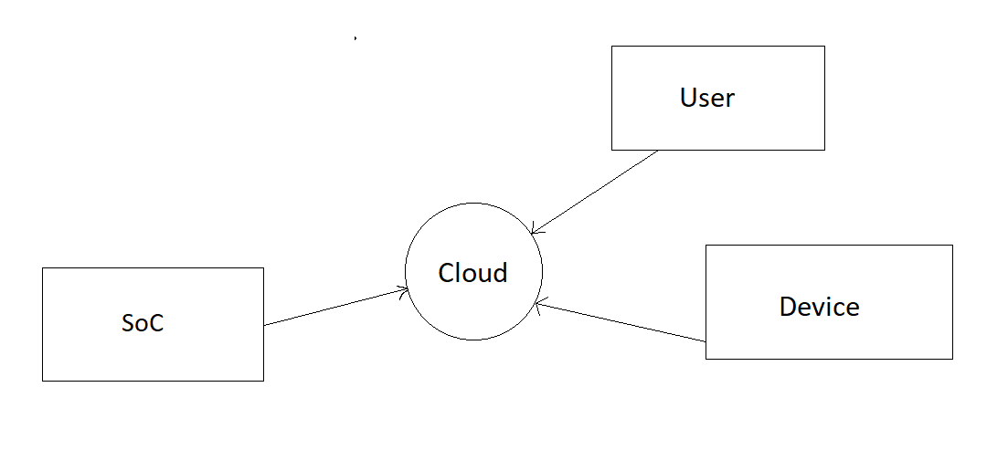

Figure 1: Model’s system architecture

The sensors will collect signals from the environment and convert them into data on the Internet. These signals will be processed, and devices such as fans, sprayers, and feeding troughs will be automatically controlled based on pre-program instructions. The manager can also monitor the barn through devices such as smartphones, laptops, etc., via the internet.

## **3.2. Device structure**

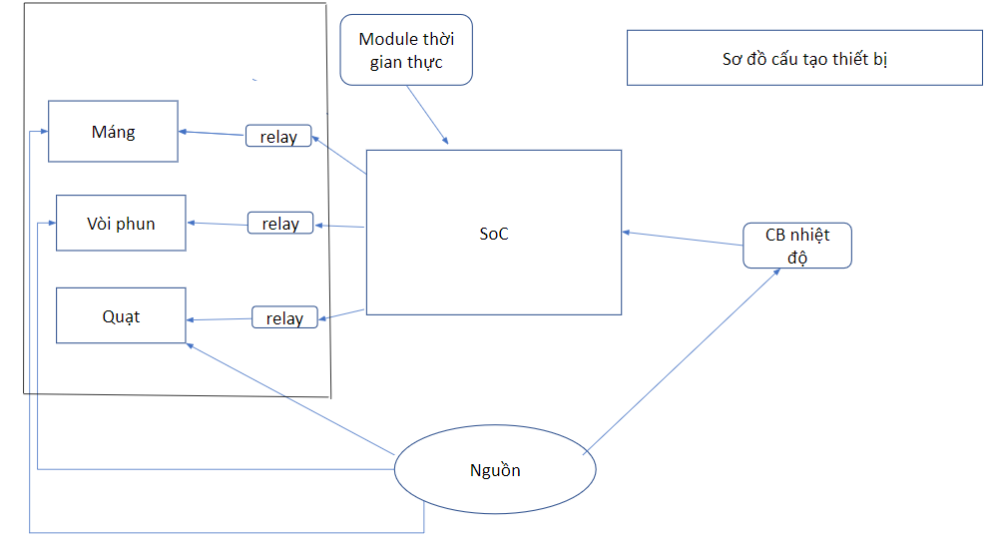

Figure 2: Model’s device structure

Intelligent pigpen system is divided into three main product groups:

● Input devices: This group functions to process signals received from temperature sensors and real-time module. These devices collect information about the temperature inside the pen and real-time data, and then process the data for analysis and control preparation.

● Output devices: This group processes commands received from the central controller and controls the devices in the pen. These devices receive commands from the central controller and perform corresponding actions such as turning on/off ventilation fans, spraying water, and feeding pigs.

● System devices: This group receives information from input signals and sends that information to cloud data storage via the Internet. This allows managers to remotely monitor through corresponding interfaces and applications. The system devices also have the ability to control output devices based on pre-programmed information to automatically adjust the environment inside the pigpen.

# **4. Materials**

## **4.1. Temperature sensor**

During the process of research and component search, we have extracted the specifications and functions of temperature sensors. From there, we can compare and select the appropriate sensor type for the project. Here are some common parameters:

* Measurement range: Consider the temperature range that the sensor can measure. Some sensors only operate within a narrow temperature range, while others can measure from very cold to very hot temperatures.
* Accuracy: The accuracy of the sensor is an important factor. The higher the accuracy, the more reliable and precise the sensor is in measuring temperature.
* Stability: Sensor stability refers to its ability to maintain accuracy over time. A stable sensor will not deviate significantly after a period of use.
* Response time: Response time is the time it takes for the sensor to provide a new temperature reading after a temperature change. A shorter response time allows the sensor to quickly respond to temperature changes.
* Durability: Sensor durability refers to its ability to withstand the operating environment and its lifespan. Temperature sensors should be able to resist factors such as vibration, impact, dust, and moisture.
* Cost: It is necessary to balance the overall cost and performance the device.

Based on the above parameters, we have selected several suitable sensors.

|  |  |  |
| --- | --- | --- |
|  | DHT22 | DHT11 |
| Picture |  |  |
| Temperature measurement | -40˚C ~ 80˚C | 0˚C ~ 50˚C |
| Moisture measurement | 0% ~ 100%(No condensation) | 20% ~ 90%(No condensation) |
| Operating voltage | 3.3V ~ 6V DC | 3.3V ~ 5V DC |
| Consumption current | About 1.5mA | About 1.5mA |
| Frequency measurement | 0.5 times/second | 1 times/second |
| Price | 35.000~80.000VND | 35.000VND |

Table 1: Comparison of 2 desired temperature sensors

**=>** The DHT11 temperature sensor is our preferred choice because, first of all, it has a low cost and is widely available in the market. It an ideal option for projects with limited resources but still delivers high efficiency. The DHT11 is also designed to be simple and easy to use, intended to operate stably and reliably in normal environments. Additionally, it offers relatively good accuracy and easy integration, supported by many microcontrollers and popular circuit boards, making it easy to incorporate into various projects. The DHT11 can be used in many different applications, including indoor temperature and humidity measurement, environmental control and monitoring, agricultural applications, and more.

## **4.2. Real time module**

|  | (RTC) DS3231 | (RTC) DS1307 |
| --- | --- | --- |
| Picture |  |  |
| Operating voltage | 3.3V or 5V DC | 5V DC |
| Consumption current | About 200µA when operating,  About 2µA when in energy saving mode | About 500µA |
| Memory | SRAM 236 bytes | SRAM 56 bytes |
| Exact time | Time error is about ± 2 minutes per year. | Time error is about ± 2 per day (depending on heat and voltage for it) |
| Gateway | I2C and SPI | I2C |
| Operating temperature | -40˚C ~ +85˚C | -40˚C ~ +85˚C |
| Price | 79.000VND | 18.000VND |

Table 2: Comparison of 2 desired real time module

## **4.3. Servo motor**

|  |  |  |  |
| --- | --- | --- | --- |
|  | RC Servo MG90s | Servo FS90R | Servo SG90 |
| Picture |  |  |  |
| Operating voltage | 4.8V ~ 6V DC | 4.8V ~ 6V DC | 4.8V ~ 6V DC |
| Rotation | 180 degrees | 180 degrees | 180 degrees |
| Spin speed | 0.11seconds/60 degrees  (at 4.8V voltage) | 0.12seconds/60 degrees  (at 4.8V voltage) | 0.1seconds/60 degrees  (at 4.8V voltage) |
| Torque | About 2 kg · cm  (at 4.8V voltage) | About 1.5 kg · cm  (at 4.8V voltage) | About 1.8 kg · cm  (at 4.8V voltage) |
| Size | 22 x 12 x 29m | 23.2 x 12.5 x 22mm | 32 x 11.5 x 30mm |
| Weight | About 13.4g | About 9g | About 9g |
| Gateway | PWM | PWM | PWM |
| Price | 65.000VND | 5.95 USD | 30.000VND |

Table 3: Comparison of 2 desired servo motor

## **4.4. Radiator fan**

|  | Radiator fan 12038 | Radiator fan 12V | Radiator fan 17251 |
| --- | --- | --- | --- |
| Picture |  |  |  |
| Wattage | 22/21W | 3.6W | 38W |
| Voltage | 220-240V | 12v DC | 220v/240v |
| Size | 120x120x38 | 40x40x10 | 172x150x51 |
| Price | 320.000VND | 15.000VND | 360.000VND |

Table 4: Comparison of 2 desired radiator fan

## **4.5. Water pump**

|  |  |  |
| --- | --- | --- |
|  | Mini pressure pump 12V | Mini pressure pump 5V |
| Picture |  |  |
| Voltage | 12V DC | 3 ~ 5V DC |
| Wattage | 5-12W | 100~200mA |
| Pump flow | 1.8l/Min | 1.2l ~ 1.6l/Min |
| Size | 90 x 40 x 35mm | 34 x 43mm |
| Price | 59.000VND | 25.000VND |

Table 5: Comparison of 2 desired water pump

## **4.6. Microcontroller**

|  |  |  |  |
| --- | --- | --- | --- |
| MCU | Arduino Uno R3 | Raspberry Pi 4 Model B | ESP8266 |
| Picture |  |  |  |
| Quantity foot | 14 foot | 40 foot | 17 foot |
| Processing speed | 16 MHz | 1.5GHz | 80MHz |
| Microprocessor | ATmega328P | Boardcom BCM2711 | Tensilica L106 32-bit RISC |
| RAM | 2KB | 1GB,2GB or 4GB | 80KB |
| Internal memory | 32KB | Micro SD card | 4MB |
| Gateway | UART,SPI,I2C,ADC | Wi-Fi 802.11c & Bluetooth 5.0 | Wi-Fi, UART,SPI,I2C,ADC |
| Price | 150.000VND | 2.400.000VND | 58.000VND |

Table 6: Comparison of 2 desired microcontroller

**=>** During the research and exploration process, we have chosen to use ESP8266 because it comes with a built-in Wi-Fi module, allowing easy connection and communication with Wi networks. Additionally, ESP8266 is an affordable microcontroller with a compact design that can be integrated into small devices and embedded designs. It has high performance with fast processing speed and ample buffer memory, enabling efficient handling of complex data and network interactions while consuming low power during operation.

🡺After comparing and synthesizing components, the following are the components selected for the equipment set:

|  |  |  |
| --- | --- | --- |
| Device | Picture | Quantity |
| ESP8266 | Module IOT ESP8266 ESP-12E CH340 | Tiki | 1 |
| DHT11 | Module Cảm Biến Độ Ẩm, Nhiệt Độ DHT11 - Nshop | 1 |
| Breadboard | Breadboard Cắm 400 Lỗ 8.5x4.5cm Điện Tử 360(E360) | 2 |
| Cable 40 male - female 10cm | Dây cắm Breadboard Đực-Cái 20cm | Shopee Việt Nam | 1 |
| 12V Honeycomb Power |  | 1 |
| 12V Radiator Fan |  | 1 |
| 12V mini pump |  | 1 |
| DS1307 |  | 1 |
| Servo SG90 |  | 1 |

# **5. Cloud**

Blynk application is one of the very reasonable options because it has many advantages and useful features in developing IoT applications. First it offers a friendly user interface, making it easy for users to design and customize the control interface for IoT devices. Blynk supports many development platforms and popular embedded devices including Arduino, ESP8266, Raspberry Pi and many other microcontrollers, which can easily integrate devices into the IoT system.

In addition, Blynk supports many different communications such as Wi-Fi, Bluetooth, Ethernet and MQTT protocol, allowing the choice of communication suitable for its application. Another advantage of Blynk is security. BlyNK uses safety and authenticating methods to ensure that devices and data are protected during the communication process.

In short, Blynk is a popular and powerful IoT platform, chosen by people because of its flexibility, easy integration and friendly interface, so we decide to use the BlyNK application for the project. mine.

# **6. Design and Deploy the system**

## **6.1. Circuit diagram**

After the research and research process, here is an outline of the circuit diagram of the product with the appropriate components:

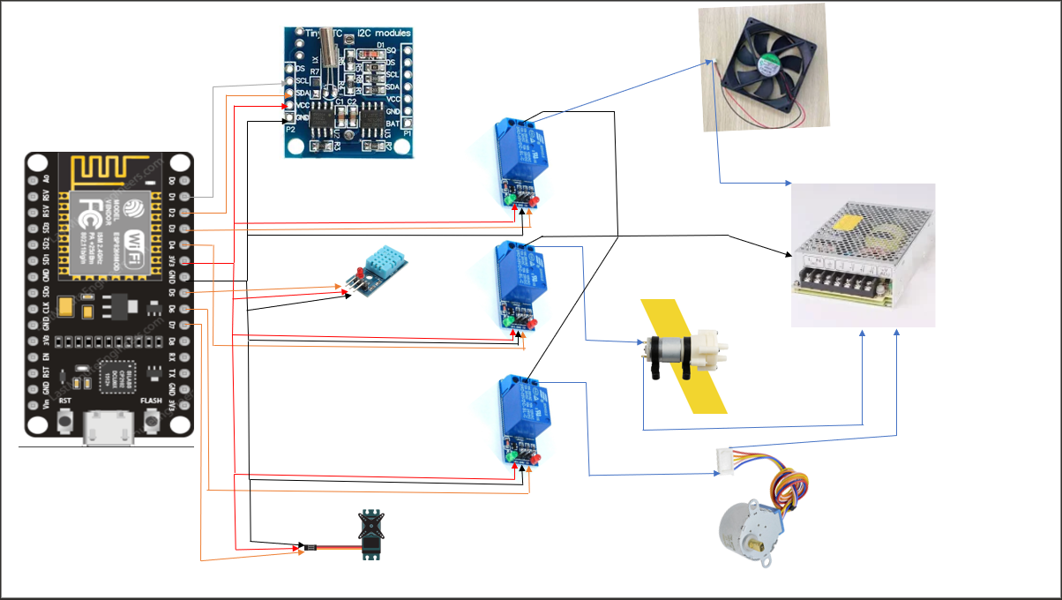

Figure 3: Diagram

Intelligent pigpen controller using Blynk, ESP8266, DHT11, DS1307 (RTC), relay, fan, pump, and feeding trough will create a smart circuit diagram system. The ESP8266 will play a key role collecting data from the DHT11 sensor to measure temperature and humidity in the pigpen. Accurate time information will be provided by the1307 (RTC) circuit and synchronized with the ESP6.

The user interface for controlling devices in the pigpen will created by the Blynk IoT platform on a mobile phone. When the manager interacts with the interface, the ESP8266 will receive signals and use the relay to turn on or off the power supply to devices such as fans, pumps, and feeding troughs. This allows remote users to adjust these devices to ensure the best environment for pigs in the pen.

## **6.2. System flowchart**

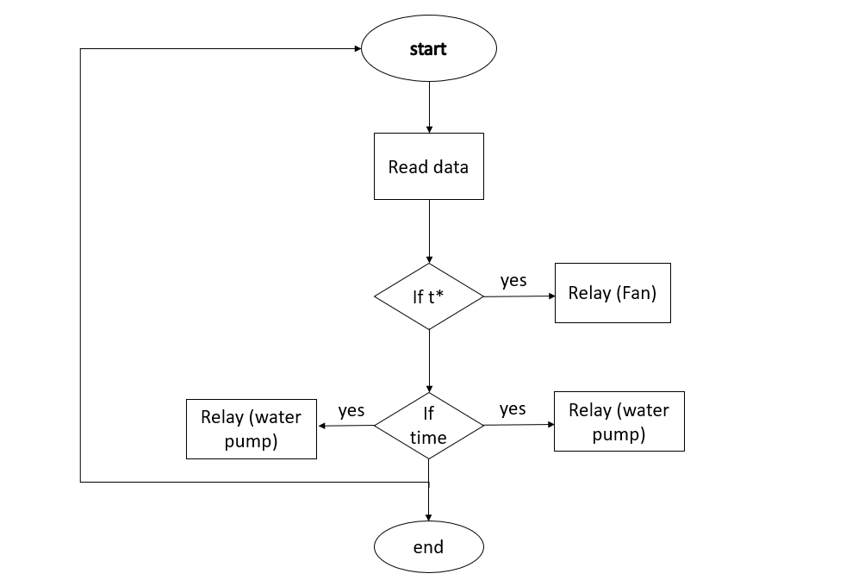

Figure 4: Model’s flowchart

The system will conduct an inspection of the environmental data inside the pigsty. In case the temperature exceeds the high threshold, the system will activate the ventilation fan system to cool down the pigsty. When the temperature reaches a suitable level, the system will turn off the fan. If it's feeding time, the system will provide food for the pigs. Finally, if it's time to clean the pigsty, the system will activate the cleaning system. This process repeated to ensure that the pigsty is managed and cared for an intelligent and efficient manner.

# **7. Results and Discussion**

## **7.1. Results**



Figure 5: Results displayed on Blynk

## **7.2. Discussion**

1. Advantages of smart pig barn control system:

* Increased production efficiency: By automatically adjusting important factors such as temperature and feed, the system creates an ideal environment for the development and growth pigs. This leads to enhanced reproductive capacity and growth, thereby improving production efficiency.
* Resource savings: The smart pig barn control system optimizes the supply of food and water pigs based on actual needs. This helps reduce waste and save resources such food and water, resulting in economic and environmental benefits.
* Intelligent monitoring and management: The system is integrated with sensors and monitoring systems track important parameters such temperature, humidity, air quality, and pig activity. Farmers can remotely monitor and control the barn through mobile devices or computers, enabling efficient barn management.
* Improved product quality: A better living environment in a smart pig barn leads to improved product quality. Pigs raised better conditions, without stress, and with good nutrition, result in higher-quality pork with fewer diseases.

1. Challenges and limitations:

* Initial investment cost: Implementing a smart pig barn control system requires a significant initial investment for purchasing and installing the system. This can be a challenge for small-scale pig farmers with limited capital.
* Training and knowledge: Using a smart pig barn control system requires farmers to have knowledge and skills to operate and manage the system. Training and understanding of this technology can be a challenge for some farmers who are not familiar with new technologies.
* Technical issues and malfunctions: Electronic systems and sensors may experience technical issues or malfunctions, affecting the operation of the smart pig barn control system. This requires technical knowledge and repair abilities to address these issues.

1. Development potential:

* Integration of artificial intelligence (AI) and machine learning: Developing a smart pig barn control system can integrate artificial intelligence and machine learning to enhance predictive capabilities and system optimization. This can bring higher efficiency and utility to the pig farming industry.
* Internet of Things (IoT) connectivity: Connecting the smart pig barn control system to the IoT network can create a connected ecosystem, allowing data transmission and interaction between different devices and systems. This opens up opportunities for enhanced automation and intelligent management in the pig farming industry.

In summary, the smart pig barn control system project brings many advantages such as increased production efficiency, resource savings, intelligent monitoring and management, and improved product quality. However, it faces challenges terms of initial investment costs, training and knowledge, as well as technical issues and malfunctions. The development potential of this technology lies in integrating artificial intelligence and machine learning, as well as IoT connectivity to create a smart and automated ecosystem in the pig farming industry.

# **8. Conclusion and development direction**

## **8.1. Conclusion**

The main objective of this project is to integrate smart devices into a system to support pig care. By deploying sensors, controllers, and data analysis algorithms, the system provides real-time monitoring, control, and optimization of environmental conditions, feeding, and health management.

The smart pigpen control system has demonstrated significant benefits such as automating tasks for feeding and cleaning the pen, reducing labor requirements, and minimizing human errors. The system maintains appropriate temperature and ventilation and intervenes in feeding.

Furthermore, the system has enabled data collection and analysis, generating valuable information for pig farmers to make informed decisions.

## **8.2. Development direction**

In the future, there are several areas that need to be focused on to develop and improve the smart pig barn control system:

1. Integration with IoT and Cloud Technology: Enhance connectivity and scalability by integrating the system with Internet of Things (IoT) devices and cloud platforms. This integration will enable remote monitoring and control, data storage and analysis, and facilitate collaboration among multiple stakeholders.

2. Enhance Data Analytics: Continuously improve the data analytics capabilities of the system. Develop more sophisticated algorithms to extract useful insights from the collected data, such as predicting growth rates, optimizing feed formulas, and identifying early disease outbreaks.

3. Expand Sensor Capabilities: Explore additional sensor technologies to expand the range of monitored parameters. For example, integrating cameras or computer vision systems can allow monitoring of pig behavior and health indicators, while sound sensors can detect abnormal sounds or emergency signals.

4. Integration with Supply Chain Management: Establish connections with supply chain management systems to ensure traceability, health status, and quality of pigs. This integration can help track the origin, health status, and quality of pigs, providing valuable information for consumers and ensuring compliance with regulations.

5. Collaboration and Knowledge Sharing: Prom collaboration among researchers, pig farmers, and technology providers to share best practices, exchange knowledge, and drive innovation in smart pig farming. This collaboration can lead to the development of standardized protocols, benchmarks, and industry-wide improvements.

By focusing on these areas, the smart pig barn control system can continue to evolve and contribute to the advancement of sustainable and efficient pig farming methods, benefiting both pig farmers and consumers.

# **References**

[1]<https://nhachannuoi.vn/tong-quan-tinh-hinh-chan-nuoi-nam-2022/>

[2]<https://nhachannuoi.vn/stress-nhiet-tren-heo-nuoi-cong-nghiep-va-bien-phap-phong-tranh/>

[3]<https://nhachannuoi.vn/bien-phap-quan-ly-va-ve-sinh-trong-phong-benh-chan-nuoi-heo/>

[4][5]<https://nhachannuoi.vn/bien-phap-quan-ly-va-ve-sinh-trong-phong-benh-chan-nuoi-heo/>

[6][https://nhachannuoi.vn/cac-yeu-to-anh-huong-den-ty-le-chuyen-doi-thuc-an-fcr-o-lonlon/](https://nhachannuoi.vn/cac-yeu-to-anh-huong-den-ty-le-chuyen-doi-thuc-an-fcr-o-lon/)

[7]<https://nguoichannuoi.vn/kien-thuc/cho-heoheo-an-uong-dung-cach/#:~:text=%E2%80%93%20Cho%20%C4%83n%20%C4%91%C3%BAng%20b%E1%BB%AFa%2C%20ng%C3%A0y,n%C3%AAn%20thay%20%C4%91%E1%BB%95i%20t%E1%BB%AB%20t%E1%BB%AB.>

# Table of Contents

Abstract 1

1. Introduction 2

1.1. Rationale of the Study 2

1.2. Introduction to the project 2

2. Features 3

2.1. Cooling system 3

2.2. Water pump system 4

2.3. Feeding trough 5

3. Proposed design methodology 6

3.1. System architecture 6

3.2. Device structure 7

4. Materials 8

4.1. Temperature sensor 8

4.2. Real time module 10

4.3. Servo motor 11

4.4. Radiator fan 12

4.5. Water pump 12

4.6. Microcontroller 14

5. Cloud 17

6. Design and Deploy the system 17

6.1. Circuit diagram 17

6.2. System flowchart 19

7. Results and Discussion 20

7.1. Results 20

7.2. Discussion 20

8. Conclusion and development direction 22

8.1. Conclusion 22

8.2. Development direction 22

References 23

Table of Contents 24

List of Figures 25

List of Table 25

L**ist of Figures**

Figure 1: Model’s system architecture…………………………………………………….6

Figure 2: Model’s device structure……………………………………………………......7

Figure 3: Diagram……………………………………………………………………......18

Figure 4: Model’s flowchart…………………………………………………………......19

Figure 5: Results displayed on Blynk……………………………………………………20

# **List of Table**

Table 1. Comparison of 2 desired temperature sensors.......................................................9

Table 2. Comparison of 2 desired real time module..........................................................10

Table 3. Comparison of 2 desired servo motor..................................................................11

Table 4. Comparison of 2 desired radiator fan..................................................................12

Table 5. Comparison of 2 desired water pump..................................................................13

Table 6. Comparison of 2 desired microcontroller............................................................14